**Leaf Water Potential in Mixed Mediterranean Forest from Unmanned Aerial Vehicle (UAV)-Based Hyperspectral Imaging and Machine Learning**

M.Sc. Thesis

Submitted to the Robert H. Smith Faculty of  
Agriculture, Food & Environment  
  
The Hebrew University of Jerusalem

For the Degree  
'Master of Sciences'

By

Netanel Fishman

Rehovot June 2025

This work was conducted under the guidance of:

Dr. David Helman

Department of Soil and Water Sciences, Institute of Environmental Sciences,

The Robert H. Smith Faculty of Agriculture, Food and Environment,

The Hebrew University of Jerusalem

Acknowledgments

First and foremost, I wish to express my deepest gratitude to the institutions that funded this research and supported me through scholarships during my studies: the Jewish National Fund (KKL), the Dean of the Faculty of Agriculture, and the Appleby Foundation.

I am profoundly grateful to my advisor, Dr. David Helman, for his dedicated guidance and for being a true inspiration. His ability to think and communicate with clarity, act with efficiency, and maintain an ever-curious and critical approach has left a lasting impression on me. My gratitude is especially deep for his tremendous understanding and unwavering support during my extended military reserve service in the days of the Swords of Iron war. His expertise and dedication have been instrumental in shaping this work, and I am truly fortunate to have had the opportunity to learn under his mentorship.

I would like to extend my heartfelt thanks to the members of Tamir Klein’s Tree Lab at the Weizmann Institute of Science, who conducted the field measurements of leaf water potential. In particular, I am grateful to Sofie Obersteiner, Assaf Yaakobi, Laura Rez, and, of course, Tamir Klein himself. Your partnership in this research, insightful advice, and kind spirit have been invaluable.

Among my lab colleagues, I want to give special thanks to my research partners. Yehuda Yungstein, whose expertise in machine learning greatly enriched this study, and Gabriel Mulero—"the man in the garden"—whose assistance during forest measurements, writing, and thoughtful advice (even at the most unconventional hours) was truly indispensable. I am also deeply grateful to the rest of the lab members—Eitan Fass, Omer Burstein, Yedidya Harris, Dmitry Yusenko, Fedor Egorov, Yaron Michael, and Karin Nissim—who together create an incredible lab environment, always ready to offer advice or, at the very least, share in both the joyful and challenging moments.

A special thank you goes to the lab manager, Gil Lerner, whose expert piloting of the drone and ever-reliable problem-solving—always accompanied by a smile—were crucial to this work. Alongside him, I wish to thank Itzik Ben-Shabbat from IDO for his invaluable assistance with the drone operations and flight permits.

And finally, my deepest gratitude goes to the Creator of the world, “the God who has been my shepherd all my life to this day", for the privilege of living, learning, and exploring His creation.

Abstract

Leaf water potential (leaf) is a key indicator of plant water status, but its measurement is labor-intensive and limited in spatial coverage. While remote sensing has emerged as a useful tool for estimating vegetation water status, leaf remains unexplored, particularly in mixed forests. In this research, I used spectral indices derived from unmanned aerial vehicle-based hyperspectral imaging and machine learning algorithms to assess leaf in a mixed, multi-species Mediterranean forest comprised of five key woody species: *Pinus halepensis*, *Quercus calliprinos*, *Cupressus sempervirens*, *Ceratonia siliqua*, and *Pistacia lentiscus*. Hyperspectral images (400-1000 nm) were acquired monthly over one year, concurrent with leaf measurements in each species. Twelve spectral indices and thousands of normalized difference spectral index (NDSI) combinations were evaluated. Three machine learning algorithms – Random Forest (RF), eXtreme Gradient Boosting (XGBoost), and Support Vector Machine (SVM) – were used to model leaf. Machine learning model results were compared with linear models based on spectral indices and NDSI. SVM, using species information as a feature, performed the best with a relatively good leaf assessment (R2 = 0.53; RMSE = 0.67 MPa; rRMSE = 28%), especially considering the small seasonal variance in leaf ( = 0.8 MPa). Predictions were best for *Cupressus sempervirens* (R2 = 0.80) and *Pistacia* *lentiscus* (R2 = 0.49), which had the largest leaf variances ( $±σ$ > 1 MPa). Aggregating data at the plot scale in a ‘general’ model markedly improved the leaf model (R2 = 0.79, RMSE = 0.31 MPa; rRMSE = 13%), providing a promising tool for monitoring mixed forest leaf. The fact that a non-species-specific, ‘general’ model could predict leaf implies that such a model can also be used with coarser resolution satellite data. This study demonstrates the potential of combining hyperspectral imagery with machine learning for non-invasive leaf estimation in mixed forests while highlighting challenges in capturing interspecies variabsility.

# Table of Contents

Acknowledgments 3

Abstract 4

Table of Contents 5

Abbreviations 6

1. Introduction 7

1.1. Research Questions 10

1.2. Research Objectives 10

1.3. Research Hypotheses 10

2. Data and Methods 11

2.1 Study Site and Experimental Design 11

2.2. Field Measurements 12

2.3. UAV Platform and Spectral Data Acquisition 13

2.4. Spectral Data Processing 13

3. Predictive Models 15

3.1. Spectral Indices 15

3.2. Machine Learning Algorithms 18

3.3. Statistical analysis 20

4. Results 21

4.1. Leaf Water Potential Dynamics and Correlation with Spectral Indices 21

4.2. Machine Learning Models 23

4.3. Averaging Data at the Plot Scale 26

5. Discussion 28

6. Summary and Conclusion 31

7. References 33

Supplements 40

תקציר 42

# Abbreviations

leaf: Leaf Water Potential

EVI2: Enhanced Vegetation Index Version 2

GNSS: Global Navigation Satellite System

IMU: Inertial Measurement Unit

JNF: Jewish National Fund

MAE: Mean Absolute Error

ML: Machine Learning

MLR: Multivariable Linear Regression

NDSI: Normalized Difference Spectral Index

NDVI: Normalized Difference Vegetation Index

NDWI: Normalized Difference Water Index

NDWSI: Normalized Difference Water Stress Index

PPK: Post-Processing Kinematic

PRI: Photochemical Reflectance Index

RF: Random Forest

RGB: Red Green Blue (color model)

RMSE: Root Mean Squared Error

RPD: Residual Prediction Deviation

rRMSE: Relative Root Mean Squared Error

RTK: Real-Time Kinematic

SBET: Smoothed Best Estimated Trajectory

SVM: Support Vector Machine

TVDI: Temperature Vegetation Dryness Index

UAV: Unmanned Aerial Vehicle

VIS-NIR: Visible-Near Infrared

WI: Water Index

XGBoost: eXtreme Gradient Boosting

POS: Position and Orientation System

NIR: Near Infrared

SWIR: Short-Wave Infrared

**1.** Introduction

Forests increasingly face harsh conditions, leading to worldwide tree mortality in the last decades (Allen et al., 2010). This trend is expected to aggravate under projected climate change. Rising temperatures and altered precipitation patterns will induce severe drought conditions in many regions (IPCC, 2023). Despite their adaptation capacity, many forest species might not cope with such conditions, leading to a decline in growth rates and increased mortality (Klein et al., 2019; Patsiou et al., 2020). Monitoring forests’ water status is vital to facing such expanded adverse effects. This requires developing accurate, efficient, and large-scale assessment methods (Hartmann et al., 2018).

One of the most valuable metrics for characterizing drought stress and water status in woody species is the leaf water potential (leaf). leaf represents the degree of stability of the water in the xylem transport conduits of the trees by becoming more negative as the drought stress increases (Jarvis, 1976). leaf is a key indicator of plant water status and can provide valuable insights into the severity of drought stress experienced by the tree (Sack et al., 2016). However, measuring leaf in the field is a time-consuming and labor-intensive process, typically involving the use of pressure chambers on individual leaves (Scholander et al., 1965). This approach limits the spatial coverage and temporal resolution of leaf measurements, making it challenging to capture the heterogeneity of drought stress within and across forest stands.

Remote sensing offers a promising solution to this challenge, enabling the rapid and non-invasive assessment of vegetation status across large areas (Kerr & Ostrovsky, 2003; Konings et al., 2019). Hyperspectral reflectance information obtained from satellites or drone-based sensors has been widely used to estimate various plant traits, including leaf area index, chlorophyll content, water content, transpiration rate, and water use efficiency (Anderson et al., 2010; Asner et al., 2017; Ceccato et al., 2001; Coops et al., 2003; Helman et al., 2022; Helman & Mussery, 2020a; Konings & Gentine, 2017; Ullah et al., 2012; Zarco-Tejada et al., 2003). The physical basis for using spectral information to estimate plant traits is based on the interaction of light with plants’ biophysical and biochemical characteristics. Plant traits corresponding to water content or stress can directly influence absorption in the NIR region, particularly around the 970 nm and 1200 nm water absorption bands, and also in the SWIR, particularly 1450, 1900, and 1950 nm (Roberts et al., 2011). Other indirect responses of water-related stress that may lead to variations in pigment concentrations within the plant’s intercellular organelles primarily affect reflectance in the visible range (Thenkabail et al., 2018).

Thus, several studies have explored the potential for using spectral vegetation indices, a mathematical combination of two or more bands derived from remote sensing data, to assess leaf across vegetation types. Raj et al. (Raj et al., 2021) detailed several water absorption bands in the visible and NIR regions useful for monitoring water-related variables like leaf. They identified seven bands in the 400-1000 nm, which are sensitive to vibrational overtone frequencies of O-H bonds of water molecules, and created four normalized indices that showed a high correlation to the leaf water content of Maize crops. Peñuelas et al. (Peñuelas et al., 1996) developed the water band index based on near-infrared (NIR) reflectance (R­970/R900) to estimate leaf under salinity stress conditions. Stimson et al. (Stimson et al., 2005) demonstrated that drought stress in two tree species (Pinus edulis and Juniperus monosperma) could be quantified using indices incorporating 980 nm and 1200 nm wavelength bands, significantly correlated with the measured leaf. Italiano et al. (Italiano et al., 2023) showed corresponding temporal patterns that had a positive linear relationship with earlywood hydraulic diameter (linked to water conductivity) in drought-prone Mediterranean forests using common vegetation indices such as NDVI, EVI, and NDWI.

Additionally, Othman et al. (Othman et al., 2014), analyzing Landsat satellite imagery, found that the shortwave infrared (SWIR) band ratio effectively predicted leaf in pecan orchards. More recently, using three SWIR bands, Wang et al. (Wang et al., 2020) proposed a modified vegetation index ((R1740-R2370)/(R1740-R1750)), which showed a strong correlation with leaf across different leaf structures. Such a myriad of studies, among others, suggest that remotely sensed spectral data could be successfully used for monitoring leaf in complex systems such as mixed forests. Yet, such complex systems may require models that account for non-linear relationships between the remotely sensed data and leaf.

Machine learning techniques have shown great promise for modeling plant water content and status using remote sensing data. Machine learning algorithms can effectively capture the complex and nonlinear relationships between spectral reflectance patterns and plant physiological traits (e.g., Li et al., (J. Li et al., 2023)). Several studies have successfully applied machine learning algorithms such as random forests (RF), support vector machine (SVM), and artificial neural networks (ANN) to predict leaf water content, relative water content, and equivalent water thickness from hyperspectral and multispectral imagery (W. Li et al., 2023; Sadiq et al., 2023; Virnodkar et al., 2020).

Despite the progress made in applying remote sensing to assess leaf, there remains a gap in our understanding of how these techniques perform in diverse, mixed-species forests at high spatial resolutions (<1 m). To the best of our knowledge, no study has combined high-spatial-resolution remote sensing data acquired from sensors onboard unmanned aerial vehicles (UAV) with machine learning algorithms to predict leaf in mixed forest stands. Many Mediterranean forests, for example, are characterized by a complex mosaic of woody species with varying drought tolerances and water use strategies (Peñuelas et al., 2017; Rog et al., 2021). To accurately assess the water status of these forests, it is necessary to develop remote sensing methods that can account for such heterogeneity and species-specific leaf at fine spatial scales (Lapidot et al., 2019). Then, generated leaf maps could be used to point at specific stands or stand areas under stress conditions, allowing for precursory intervention. This is particularly important in places like Israel, where about half of the forested areas are planted and managed by the Jewish National Fund (JNF; (Amir & Rechtman, 2006)). Such monitoring can help detect stands under stress and treat the stands with irrigation or thinning the stand density under pressure (Fassnacht et al., 2016; Pozner et al., 2022).

Here, I addressed the above research gap by examining the use of high-spatial-resolution UAV-derived hyperspectral imagery taken over a year in open-field experimental plots to assess leaf in five key Mediterranean woody species. In this study, I developed machine learning models based on the hyperspectral data and field leaf measurements and compared the models with commonly used spectral indices to assess leaf. The ability of spectral reflectance data and machine learning models to capture plot and species-specific leaf changes were evaluated. The study was based on two hypotheses: (1) that leaf would be easier to model for species with a broader range of leaf values than species displaying a narrow range of values, and (2) that machine learning algorithms should significantly enhance the ability to predict leaf compared to simple linear regression models using spectral indices, particularly those based on non-linear relationships. Following is a detailed description of the research questions, objectives, and hypotheses.

## 1.1. *Research Questions*

*RQ1.1:* How do drought conditions affect the seasonal patterns of leaf in five key Mediterranean woody species?

*RQ2.1:* What is the most effective method to minimize hyperspectral interference of non-representative pixels from woody canopies?

*RQ2.2:* Which spectral reflectance bands (wavelengths) best contribute to an index accurately representing leaf?

*RQ2.3:* Can the coarser spatial resolution of satellites be used to assess drought stress in heterogeneous Mediterranean mixed forest stands for practical forest management?

## 1.2. Research Objectives

**Ob1** To monitor drought stress via leaf in five key woody species of a Mediterranean mixed forest in Israel.

**Ob2** To model leaf using hyperspectral data acquired from a sensor onboard a drone (high spatial resolution) and translate the model for use with a coarser resolution satellite imaging.

## 1.3. *Research Hypotheses*

Changes in tree status due to drought stress can be detected early from spectral signals. Thus, high spatial resolution hyperspectral dataacquired from sensors mounted on drones and satellites can be used to model water stress metrics, such as leaf as proxies of tree hydraulic failure, providing an early alert of potential tree die-offs.

# **2. Data and Methods**

## 2.1 Study Site and Experimental Design

The experiment was conducted in Yishi Forest, a semi-arid mixed Mediterranean forest in the Judean foothills, Israel (Lapidot et al., 2019; Rog et al., 2024). The forest is located 4 km south-west of Beit Shemesh, Israel (31° 43 ́N 34° 57 ́E, Fig. 1), and covers an area of ~650 ha with an average elevation of 300 m a.s.l. and a mean annual precipitation of 460 mm yr−1 (annual mean of the last 20 years). Precipitation occurs mostly from November to May. The mean annual temperature is 20.4±6.8 °C, with mean winter (January – March) and summer (June – August) temperatures of 16.5±1.9 °C and 24.1±7.9 °C, respectively (Israel Meteorological Service). The predominant soil type in Yishi is terra rossa, which consists of A and C soil horizons, with C horizon soil penetrating the cracks between the weathered limestone bedrock. Soil depth (A horizon) is $\sim$ 21 cm, ranging from 16 to 25 cm (Rog et al., 2021).



**Figure 1.** (**a**) The study area and the five key Mediterranean woody species comprising Yishi Forest, which includes (**b**)Pine (*Pinus halepensis*), (**c**) Oak (*Quercus calliprinos*), (**d**)Cypress (*Cupressus sempervirens*), (**e**) Carob (*Ceratonia siliqua*), and (**f**)Pistacia (*Pistacia lentiscus*). (**g**)An RGB image derived from the hyperspectral camera onboard an M600 Pro UAV showing the six plots in the studied area.

The vegetation in Yishi is dominated by the planted gymnosperm woody species *Pinus halepensis* (Fig. 1b) and *Cupressus sempervirens* (Fig. 1d)*,* as well as the local Mediterranean angiosperm woody species *Quercus calliprinos* (Fig. 1c), *Ceratonia siliqua* (Fig. 1e), and *Pistacia lentiscus* (Fig. 1f). In the following, we will refer to these key woody species by their common English names: Pine*,* Cypress*,* Oak, Carob*,* and Pistacia. These woody species were formerly studied *in situ* in terms of their water relations and carbon management ((Rog et al., 2021, 2024), respectively). The forest understory supports a diverse array of annual plants that flourish from winter to spring.

Six plots, each ~0.05 ha in area, were established within the forest, comprising the five co-occurring woody species (Fig. 1g). The plots were divided into two treatments, three plots subjected to rainfall reduction to simulate drought conditions and three control plots under normal rainfall conditions. The rainfall reduction treatment involved installing an open-pipe harvesting system to divert approximately 50% of incident precipitation from the treated plots. Nevertheless, considering the drought-adapted woody species studied here, treatment effects were not expected within the first few years, as reported for a nearby site (Sternberg et al., 2017). Therefore, treatments are not considered in the analysis of this paper, but rather, data from both treatments was used together to broaden the range in leaf to enable more robust modeling.

## 2.2. Field Measurements

leaf was measured using the pressure chamber technique (Boyer, 1967). It involves enclosing a leaf petiole in a sealed chamber and gradually increasing the pressure inside the chamber until the sap is observed emerging from the cut surface of the petiole. The pressure at which this occurs is equal to the negative of the leaf water potential, providing a direct measurement of the water status within the leaf (Ritchie & Hinckley, 1975). Measurements were conducted monthly between October 2021 and March 2023 from 11:00 AM to 1:00 PM to capture maximum daily leaf values across the season. leaf was measured once per date in all 30 trees used in this study (five species in six plots). In a preliminary trial, we measured five leaves per individual tree on a subset of the studied trees. Variations in leaf among leaves sampled from the same tree were in the magnitude of 2-7%. A major consideration of the field measurements was to complete all measurements within the shortest time possible to avoid significant diurnal variations among the samples. This is paramount when comparing individuals and species in a single day. Thus, to complete the measurements of all 30 trees within 60-90 minutes (representing similar temperature, humidity, and radiation conditions), having a single pressure chamber instrument and two workers, and following the small leaf variability observed in our trial, we opt to sample a single leaf per tree (per date). Excised leaves were immediately placed in airtight plastic bags and kept cool to minimize measurement errors from time lags. A total of 30 leaves were sampled per date and measured using a PMS1515 pressure chamber (PMS, Albany, OR, USA). The total number of sampled leaves during the study period was 480 (16 months, 30 leaves per date).

## 2.3. UAV Platform and Spectral Data Acquisition

Hyperspectral imagery was acquired monthly concurrent with the leaf measurements starting from March 2022 to February 2023, using a Nano-Hyperspec camera (Headwall Photonics, Boston, MA, USA) mounted on a ﻿DJI Matrice 600 Pro (M600) Hexacopter. ﻿The NanoSpec sensor is a push-broom hyperspectral nano-sensor with 274 spectral bands and 640 spatial pixels within the visible-near-infrared range from 400 nm to 1000 nm. The M600 is controlled via a hand-held remote-control transmitter and a ground control station with a navigation data link, which sends waypoint navigation information to the aircraft from a laptop computer. The M600 carries a Global Navigation Satellite System (GNSS) and an Inertial Measurement Unit (IMU) (SBG Systems North America, Inc., Chicago, IL).

The images were collected between 11:00 AM and 1:00 PM, concurrent with the leaf measurements, at the height of 60 m above ground level, providing a spatial resolution of 2-3 cm per pixel. ﻿Three flights were required to cover the study area. For radiometric calibration, a 3 m by 3 m in-situ grey-white reflectance calibration with three strips and distinct reflectance factors (56%, 30%, and 11% reflectance) was set up within the flight scene in each campaign (date). For geometric corrections, a ground-based GNSS receiver – Trimble SPS585 precision RTK (Trimble Inc., Westminster, Colorado - USA) – was used to collect static geolocation data to calculate the post-processing kinematic (PPK) flight trajectory using a smoothed best-estimated trajectory (SBET) file generated from the POSpac UAV™ Version 8.9 software tool (Applanix, Richmond Hill, Ontario, Canada).

## 2.4. Spectral Data Processing

Radiometric calibration, geometric corrections, and ortho-mosaicing were applied to the raw hyperspectral image cubes via the SpectralView software version 3.1.4 (Headwall Photonics, Fitchburg, MA, USA). Shades and non-vegetated areas within the image (Fig. 2a) were masked using the Quantum Geographic Information System (QGIS version 3.32.3, Free Software Foundation, Boston, USA). First, the normalized difference vegetation index (NDVI) was calculated, and pixels with NDVI < 0.3 were excluded to eliminate soil and understory vegetation (Fig. 2b). Then we used near-infrared (NIR) reflectance values below a threshold of 0.07-0.2 to eliminate shaded parts in the canopy since these affect the spectral signal albeit leaf changes. We found these thresholds suitable for that purpose following trial and error after visually inspecting the clipped RGB (Fig. 2c).



**Figure 2.** Example for masking non-representative pixels within our processing pipeline. (a) The original image with polygons of area of interest for specific tree species, and non-representative pixels. (b) After masking pixels with NDVI<0.3; green vegetation and shaded pixels are left. (c) Final product after masking pixels with low NIR reflectance for dealing with shaded pixels.

The reflectance values of retained pixels were averaged for each tree canopy, which was manually delineated, to obtain a single mean reflectance spectrum representing the entire canopy. The Savitzky-Golay filter (Savitzky & Golay, 1964), with a window size of 20 bands and second-order polynomials, was applied to eliminate potential artifacts and anomalies in the spectral signatures caused by measurement errors (Fig. 3).

After the spectral data processing, the final dataset used within the modeling pipeline resulted in a sample size of N = 246. The data was randomly split into a 70% training set and a 30% test set for model training and evaluation purposes. This ratio is considered useable and generic within an ML pipeline, especially if one wants a larger data sample to evaluate the model and ensure a more robust transferability to other locations and cases.



**Figure 3.** Spectral signatures in the 400–1000 nm range (**a**)beforeand (**b**) after applying theSavitzky-Golay filter smoothing. Each line in the graph corresponds to the averaged signature over all pixels in the canopy per each species and date.

# 3. Predictive Models

We followed two approaches to predict leaves from the hyperspectral data. First, we used a simple regression approach, whereas the predictor is a spectral index, whether derived in previous studies or generated in this study for all species together as well as for individual species (see sub-section *3.1*). For the same datasets, we also tested the best NDSI, adding one index at a time within a multivariable linear regression (MLR) model. Second, we used the best NDSIs generated from the hyperspectral data in three machine learning algorithms (sub-section *3.2*).

## 3.1. Spectral Indices

Twelve known spectral indices within the 400–1000 nm range were tested by conducting a simple linear regression with leaf. The selected indices were based on their ability to directly and indirectly predict water-related plant traits (Azar et al., 2023; Helman et al., 2017; Peñuelas et al., 1993; Sadeh et al., 2024). The normalized difference vegetation index (NDVI), the photochemical reflectance index (PRI), and the enhanced vegetation index version two (EVI2) were tested for their ample use in monitoring vegetation status and dynamics, which showed to be indirectly related to water stress through biophysical changes (Azar et al., 2023; Helman et al., 2018; Mulero et al., 2023). COSBNDI, FOSBNDI, SAPSBNDI, and WASCOSBNDI, which were developed based on seven identified bands sensitive to the vibrational overtone frequencies of O-H bonds of water molecules, were tested due to their strong link to leaf water content (Raj et al., 2021). We also used the normalized difference water stress index (NDWSI) and the normalized difference water index (NDWI) because they have shown to be sensitive to plant water status via canopy structural changes (Azar et al., 2023; Jr et al., 2011). There are several versions of NDWI (Gao, 1996; Helman & Mussery, 2020b; McFeeters, 1996). Here, we used the one based on the 540 and 803 nm bands (Table 1), which incorporates the responses from the visible region of the spectrum (the green band) with canopy structural changes within the NIR region to water-related responses since our hyperspectral data were restricted to the VIS–NIR wavelength range (400–1000 nm). Finally, the water index (WI), developed specifically to assess leaf, was tested. The WI gives information about canopy water status with a change in the 970 nm relative to the 900 nm as the water status changes in the leaves (Peñuelas et al., 1996). Table 1 summarizes the 12 spectral indices, providing their mathematical formulation.

We further leveraged the multiband option of our hyperspectral data (274 bands) and calculated thousands of combinations of a normalized difference index to identify new and possible band combinations suitable for leaf other than the already established 12 spectral indices used in this study. The normalized difference spectral index (NDSI) approach uses a two-band combination of reflectance (Inoue et al., 2008):

NDSI (unitless) = $\frac{\text{b1 }\text{– }\text{b2}}{\text{b1 + b2}}$

whereas b1 and b2 are the reflectance values of any two wavelength bands. Such a normalization mitigates the influence of varying illumination conditions, isolating the relative difference between the selected bands (Inoue et al., 2008).

Since each hyperspectral image contains 274 bands from 400 to 1000 nm, a total of 37,401 NDSI options could be derived from combining each pair of bands (i.e., 274 $×$ 273 options divided by 2 to avoid duplications with inverted order) per image per individual. Each NDSI value is used in a simple linear regression against the leaf. After this, we selected the top-performing indices yielding the highest coefficient of determination (R2).

**Table 1.** Previously published spectral indices used in this study to assess $ψ$ leaf.

|  |  |  |  |
| --- | --- | --- | --- |
| Index | Name | Formula | Reference |
| NDVI | Normalized difference vegetation index | $$\frac{{\text{ρ}}_{\text{NIR}}\text{ – }{\text{ρ}}_{\text{R}}}{{\text{ρ}}_{\text{NIR}}\text{+ }{\text{ρ}}_{\text{R}}}$$ | (Kriegler et al., 1969) |
| PRI | Photochemical reflectance index | $$\frac{{\text{ρ}}_{\text{531}}\text{ – }{\text{ρ}}_{\text{570}}}{{\text{ρ}}_{\text{531}}\text{+ }{\text{ρ}}_{\text{570}}}$$ | (Gamon et al., 1992) |
| 940/960 | Reflectance ratio of 940 and 960 nm | $$\frac{{\text{ρ}}_{\text{940}}}{{\text{ρ}}_{\text{960}}}$$ | (Elsayed et al., 2011) |
| 940/960 / NDVI | Reflectance ratio of 940/960 nm and NDVI | $$\frac{{{\text{ρ}}_{\text{940}} }/{ {\text{ρ}}_{\text{960}}}}{\text{NDVI}}$$ | (Elsayed et al., 2011) |
| EVI2 | Enhanced vegetation index 2nd version | $$\text{2.5}\left(\frac{{\text{ρ}}_{\text{NIR}}\text{ – }{\text{ρ}}_{\text{R}}}{{\text{ρ}}_{\text{NIR}}\text{+}\left(\text{6}{ \text{ρ}}_{\text{R}}\right)\text{ – }\left(\text{7.5 }{\text{ρ}}_{\text{B}}\right)\text{+1}}\right)$$ | (Jiang et al., 2008) |
| COSBNDI | Combined overtone of stretching bands – normalized difference index | $$\frac{{\text{ρ}}_{\text{660}}\text{ – }{\text{ρ}}_{\text{420}}}{{\text{ρ}}_{\text{660}}\text{+ }{\text{ρ}}_{\text{420}}}$$ | (Raj et al., 2021) |
| FOSBNDI | Forth overtone of stretching bands – normalized difference index | $$\frac{{\text{ρ}}_{\text{529}}\text{ – }{\text{ρ}}_{\text{698}}}{{\text{ρ}}_{\text{529}}\text{+ }{\text{ρ}}_{\text{698}}}$$ | (Raj et al., 2021) |
| SAPSBNDI | Small absorption peak of stretching bands – normalised difference index | $$\frac{{\text{ρ}}_{\text{750}}\text{ – }{\text{ρ}}_{\text{970}}}{{\text{ρ}}_{\text{750}}\text{+ }{\text{ρ}}_{\text{970}}}$$ | (Raj et al., 2021) |
| WASCOSBNDI | Water absorption shoulder due to combined overtone of stretching bands – normalized difference index | $$\frac{{\text{ρ}}_{\text{800}}\text{ – }{\text{ρ}}_{\text{847}}}{{\text{ρ}}_{\text{800}}\text{+ }{\text{ρ}}_{\text{847}}}$$ | (Raj et al., 2021) |
| NDWSI | Normalized different water stress index | $$\frac{{\text{ρ}}_{\text{850}}\text{ – }{\text{ρ}}_{\text{970}}}{{\text{ρ}}_{\text{850}}\text{+ }{\text{ρ}}_{\text{970}}}$$ | (Jr et al., 2011) |
| NDWI | Normalized different water index | $$\frac{{\text{ρ}}_{\text{G}}\text{ – }{\text{ρ}}_{\text{NIR}}}{{\text{ρ}}_{\text{G}}\text{+ }{\text{ρ}}_{\text{NIR}}}$$ | (Azar et al., 2023) |
| WI | Water index | $$\frac{{\text{ρ}}_{\text{970}}}{{\text{ρ}}_{\text{900}}}$$ | (Peñuelas et al., 1993) |

Note: R is Red (670 nm), G is Green (540 nm), B is Blue (480 nm), NIR is Near Infra-Red (803 nm).

First, we excluded indices that showed a high correlation for any two bands close to each other within a 10 nm interval. Then, we chose the index with the best correlation and added four more local maxima indices for all species datasets (Supplementary Fig. 1). This process was conducted at the individual tree level, with spectral data analyzed separately for each tree.

A multivariable linear regression (MLR) model is tested with the top five indices, starting with simple regression and adding one index at a time to verify the effect of increasing the number of unique bands on the linear regression model’s accuracy.

Finally, we averaged the spectral and leaf values for each plot (comprising five species) for each sampling date. We calculated a new NDSI using these plot-level averages and performed linear regressions between the spectral and the leaf data. This averaging aimed to develop models at the plot scale ('general' model). However, due to the reduction in sample size (fivefold fewer samples), machine learning models could not be applied to this dataset.

## 3.2. Machine Learning Algorithms

Only the five selected NDSIs exhibiting the highest correlation with leaf were used in three machine learning algorithms: Random Forest (RF), eXtreme Gradient Boosting (XGB), and Support Vector Machine (SVM). We did not include the known spectral indices to avoid model overfitting, as some of these indices had overlapping bands and similar formulations to the NDSIs.

RF is an ensemble learning method that constructs multiple decision trees and aggregates their predictions, accounting for variations and reducing overfitting (Breiman, 2001). XGB is a scalable tree-boosting system that builds an ensemble of weak prediction models sequentially, with each successive model aiming to correct the errors of its predecessor (Chen & Guestrin, 2016). SVM is a supervised learning algorithm that constructs hyperplanes in high-dimensional space to maximize the margin between classes. It can handle linear and non-linear relationships through kernel functions, unlike RF and XGB, which are ensemble methods, thus requiring a larger sample size than SVM, which can learn from small samples (Cortes & Vapnik, 1995; Kok et al., 2021). The key parameters driving each ML algorithm are listed in Supplementary Table 1.

All models were trained on 70% of the data (training set) using fine-tuned hyperparameter (Supplementary table 1) and cross-validation. The hyperparameter optimization for each model was performed using the scikit-learn randomgridsearchCV module. ﻿This module allows for the iterative search for the best combination of the algorithm-specific parameter(s), selecting the best estimators based on the highest-ranking performance of the models fitted. Finally, the model performance was evaluated on the remaining 30% of unseen data (test dataset) using metrics such as the coefficient of determination (R²), root mean squared error (RMSE), ratio of performance to deviation (RPD), and mean absolute error (MAE). An ensemble model (AVG) was also constructed by averaging the predictions from all individual models. Feature importance analysis was conducted to identify each model's most influential spectral indices.

In a subsequent step, species information was incorporated as a categorical variable using one-hot encoding and added to the input features (Pinhanez & Cavalin, 2022). The modeling process was repeated, including hyperparameter tuning and performance evaluation on the test set. The RMSE and R2 were calculated separately for each species to assess model performance across species.

The performance of the three machine learning algorithms (RF, XGBoost, and SVM) was compared with the performance of the linear spectral-based models. In addition, the machine learning algorithms were compared with each other, and their robustness was assessed using the residual prediction deviation (RPD; (Agussabti et al., 2020; Sahoo et al., 2022)). RPD is defined as the ratio of the standard deviation of the actual measured leaf to the RMSE. We adopted the criteria of Mouazen et al. for classifying RPD scores as follows: an RPD below 1.5 indicates that the model is not usable, an RPD between 1.5 and 2.0 indicates the possibility of distinguishing between high and low-value groups, and an RPD between 2.0 and 2.5 makes approximate quantitative predictions possible. The models were classified as good and excellent for RPD between 2.5 and 3.0 or above 3.0, respectively.

Figure 4 presents the conceptual modeling framework and schemes.



**Figure 4.** Schematics of the research framework, from the data collection to the machine learning modeling. *x* and *y* in the graph mean predictor and predicted variables, respectively. *xi* and *xii*are the predictors using the top 5 NDSI without and with species as input feature, respectively. RF, SVM, and XGB stand for random forest, support vector machine, and extreme gradient boosting algorithms.

## 3.3. Statistical analysis

The ground-truth *ψ*leaf measurements were tested for normality using a *p*-value of> 0.05 with the Shapiro–Wilk test in JMP 17 Pro statistical software (SAS Institute). All test for statistical significance of model performance was performed within the Python pipeline at *p* < 0.05.

# 4. Results

## 4.1. Leaf Water Potential Dynamics and Correlation with Spectral Indices

Observed leaf in the five species fluctuated between –1 MPa and –5 MPa and differed in magnitude as well as in their dynamics along the year (Fig. 5). For example, Pine (*Pinus halepensis*) had overall the lowest leaf, with an averaged value of –2.56 MPa over the year. Pine was also the species with the lowest inter-annual variance in leaf, along with the Carob (*Ceratonia siliqua*). In contrast, Cypress (*Cupressus sempervirens*) and Pistacia (*Pistacia* *sempervirens*) had the largest leaf variance over the year, reaching a leaf as low as –4.5 MPa during the dry months.

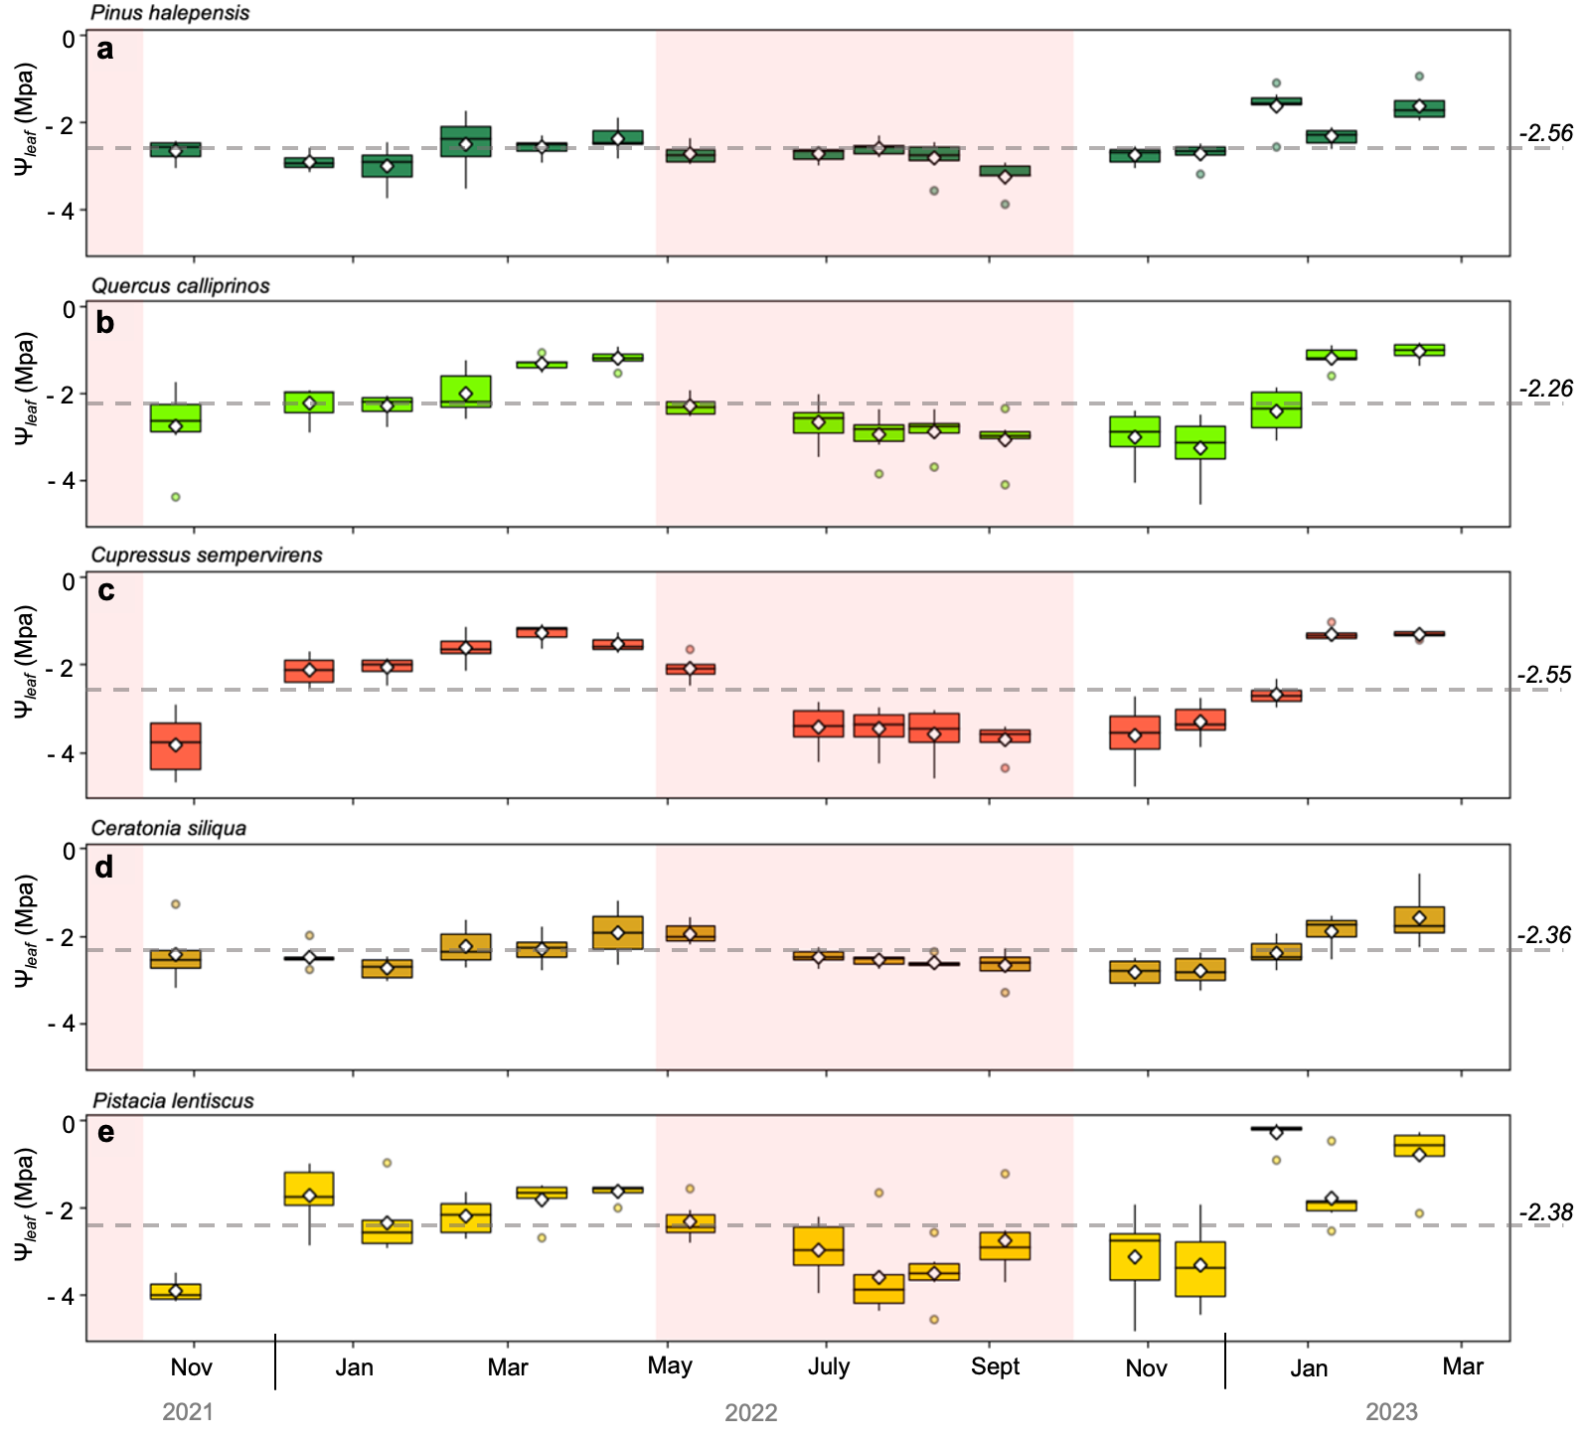

**Figure 5.** Seasonal variation of leaf throughout the study period across the five key woody species: (**a**) Pine, (**b**) Oak, (**c**) Cypress, (**d**) Carob, and (**e**) Pistacia. Each boxplot represents the interquartile range (IQR), with the horizontal line within each box indicating the median and the white diamond symbol the mean. Whiskers extend to the lowest and highest leaf within 1.5 times the IQR, and outliers are displayed as individual points. The horizontal grey dashed line represents the mean value throughout the study period, with its value in MPa next to the line. The pink shaded strips represent dry periods within the year.

Of the twelve known spectral indices, the best linear relationship was achieved with NDVI for Cypress (Pearson’s R = 0.86), while the other indices displayed only moderate to weak correlations with leaf. Pearson’s correlations indicate that some indices exhibited positive linear relationships with leaf, while others showed negative linear relationships (Table 2). The correlations did not improve when the best NDSI was used against leaf (with bands 750 nm and 680 nm; Table 2). When considering all species, the linear models with spectral indices performed poorly, with the best index being NDVI, which showed R of 0.57, along with the best NDSI.

**Table 2.** Pearson’s correlation coefficient (r) between leaf and spectral indices, including NDSI, per species and for all species together (All). Highlighted in bold are the highest R2 scores per index and the second-highest R2 scores in italics.

|  |  |  |  |  |  |  |
| --- | --- | --- | --- | --- | --- | --- |
| Index | Pine | Oak | Cypress | Carob | Pistacia | All |
| NDVI | **0.56** | **0.70** | **0.86** | ***0.53*** | 0.54 | **0.57** |
| PRI | 0.31 | –0.18 | 0.19 | –0.18 | 0.55 | 0.09 |
| 940/960 | 0.20 | 0.24 | 0.31 | 0.29 | 0.48 | 0.29 |
| 940/960 / NDVI | –0.51 | –0.65 | –*0.84* | –0.38 | –0.34 | –*0.48* |
| EVI2 | 0.23 | 0.10 | –0.08 | –0.06 | 0.24 | 0.08 |
| COSBNDI | –0.32 | –0.13 | –0.39 | –0.18 | –*0.63* | –0.29 |
| FOSBNDI | 0.41 | 0.38 | 0.63 | 0.21 | 0.50 | 0.43 |
| SAPSBNDI | 0.11 | 0.14 | 0.49 | 0.26 | 0.60 | 0.27 |
| WASCOSBNDI | –0.22 | –0.16 | 0.26 | 0.03 | 0.13 | 0.03 |
| NDWSI | 0.15 | 0.21 | 0.50 | 0.27 | 0.60 | 0.29 |
| NDWI | –0.52 | –0.65 | –0.83 | –0.51 | **–0.67** | –*0.48* |
| WI | –0.21 | –0.27 | –0.48 | –0.26 | –0.60 | –0.31 |
| NDSI (680/750) | *0.55* | *0.69* | **0.86** | **0.54** | 0.60 | **0.57** |

The MLR model performed slightly better than the spectral indices with R2 of 0.40 (compared to 0.32 for the NDVI and the best NDSI). It required nine bands and five pairs to produce the best linear regression model (Table 3).

**Table 3.** The multivariable linear regression (MLR) model performance for the highest-scored NDSI combinations. Asterisks (*) represent significant correlations at *p < 0.001*

|  |  |  |
| --- | --- | --- |
| NDSI (band1/band2) combinations | R2 | RMSE |
| 680/750 | 0.33* | 0.73 |
| 680/750, 530/623 | 0.35* | 0.72 |
| 680/750, 530/623, 660/940 | 0.35* | 0.72 |
| 680/750, 530/623, 660/940, 519/750 | 0.35* | 0.72 |
| 680/750, 530/623, 660/940, 519/750, 605/709 | **0.40\*** | **0.70** |

## 4.2. Machine Learning Models

The non-linear ML models (RF, SVM, and XGB) did not outperform MLR, but their performance improved when species was included as a feature (Table 4). The best model using species as a feature was SVM, with an R2 of 0.53 and an RPD of 1.47.

**Table 4.** Machine learning model performance, including an averaged model with the three models, as well as models with and without species as part of the features. NDSI combinations of 680/750, 530/623, 605/709, 519/750, and 660/940 were used as input. All models were significant at *p < 0.001.*

|  |  |  |  |  |  |  |  |  |
| --- | --- | --- | --- | --- | --- | --- | --- | --- |
| Model | Without species | | | | With species | | | |
| *R2* | *MAE* | *RMSE* | *RPD* | *R2* | *MAE* | *RMSE* | *RPD* |
| *RF* | 0.40 | 0.59 | 0.74 | 1.30 | 0.42 | 0.59 | 0.74 | 1.32 |
| *SVM* | 0.35 | 0.58 | 0.77 | 1.25 | **0.53** | **0.50** | **0.67** | **1.47** |
| *XGB* | 0.40 | 0.58 | 0.74 | 1.30 | 0.47 | 0.57 | 0.71 | 1.38 |
| *Averaged model* | **0.41** | **0.58** | **0.74** | **1.31** | 0.52 | 0.52 | 0.67 | 1.46 |

All four models (MLR and the three ML algorithms) performed the best with similar NDSI band combinations. However, the importance of each NDSI combination varied depending on the model, whether it included species as a feature (Fig. 6) or not (Fig. 7).

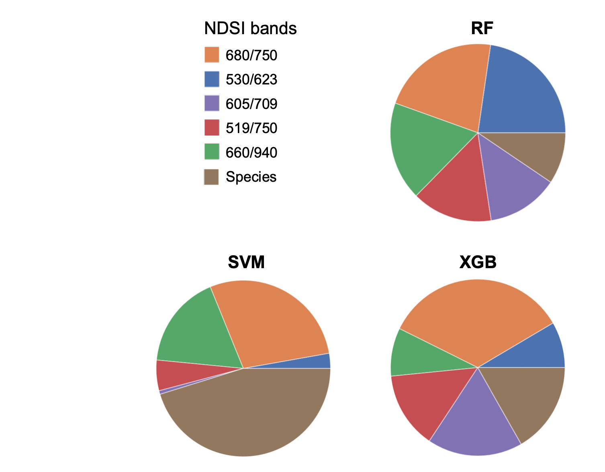

**Figure 6.** Feature importance of the NDSI pair bands in the different ML models when species was included as a feature.

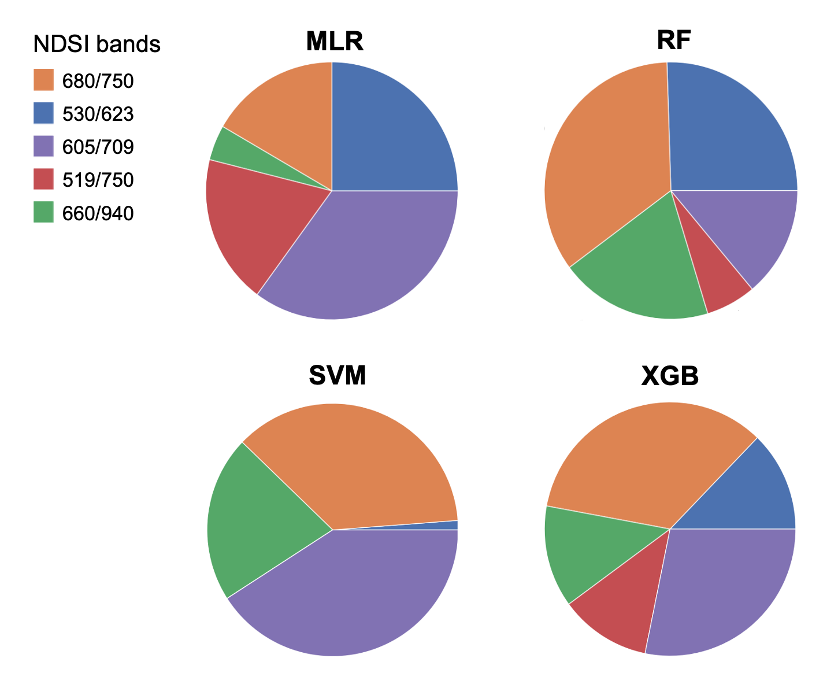

**Figure 7.** Feature importance of the NDSI pair bands in the MLR model and the different ML models when species were not included in the models.

Finally, the best ML model (SVM with species as a feature) predicted better leaf for *Cypress* and *Pistacia* than for the other species and had, specifically, low R2 for *Pine* and *Carob* (Fig. 8).



**Figure 8.** Performance of the SVM model per species: (**a**)R2 of the correlation, (**b**)RMSE in MPa.

Table 5 summarizes the first and second-best models for each species. It is noticeable that a simple model based on a spectral index (mostly NDVI and NDSI) could predict leaf, and that ML models did not significantly surpass the performance of the simple single-basis linear model while requiring much more spectral information. In addition, only *Cypress* achieved a relatively high R2 in these models.

**Table 5.** A summary of the best and the second-best models for predicting leaf, for each species and all species together (All).



## 4.3. Averaging Data at the Plot Scale

Due to the relatively moderate performance of the above species-specific models, we tested a ‘general’ model by averaging measurements over the entire plot (i.e., including all five species together). We found that NDSI with a band combination of 816 and 712 nm was the best predictor for leaf at the plot scale (Supplementary Fig. 2).

Figure 9 shows observed versus predicted leaf using this ‘general’ model. The R2 of the correlation was 0.79, with a relative RMSE of 13%, significant at *p* < 0.001.

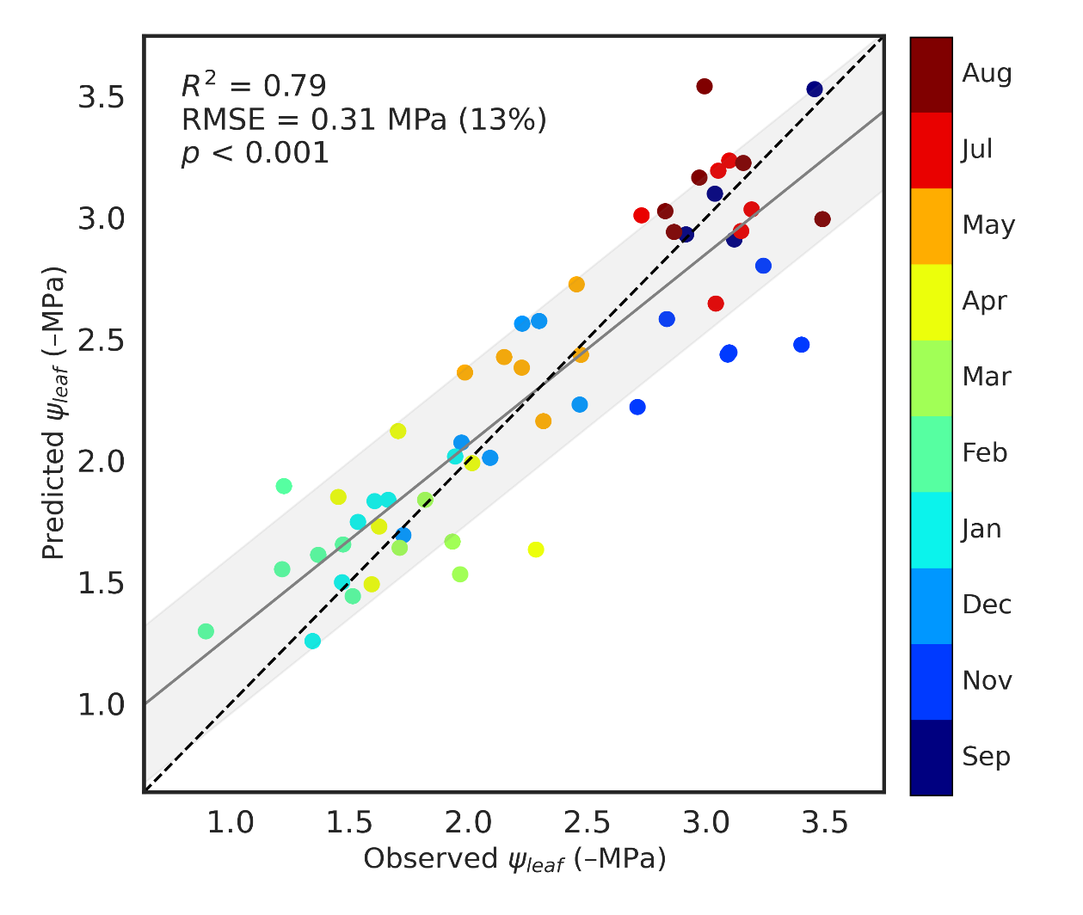

**Figure 9** Predicted vs. observed leaf for plot-aggregated data. Each dot represents the mean value for all the species in a plot on a single date. Colors mark the months of the observed/predicted value. The broken line represents a 1:1 line.

Figure 10, showing the modeled leaf using the ‘general’ model, highlights the differences in leaf among the species (*Pine* with the lowest leaf, most negative values, *Cypress* with moderately negative leaf, and *Carob* with the least negative leaf values) and between the seasons (more negative values in September, at the end of the dry season, than in May, at the end of the rainy season).

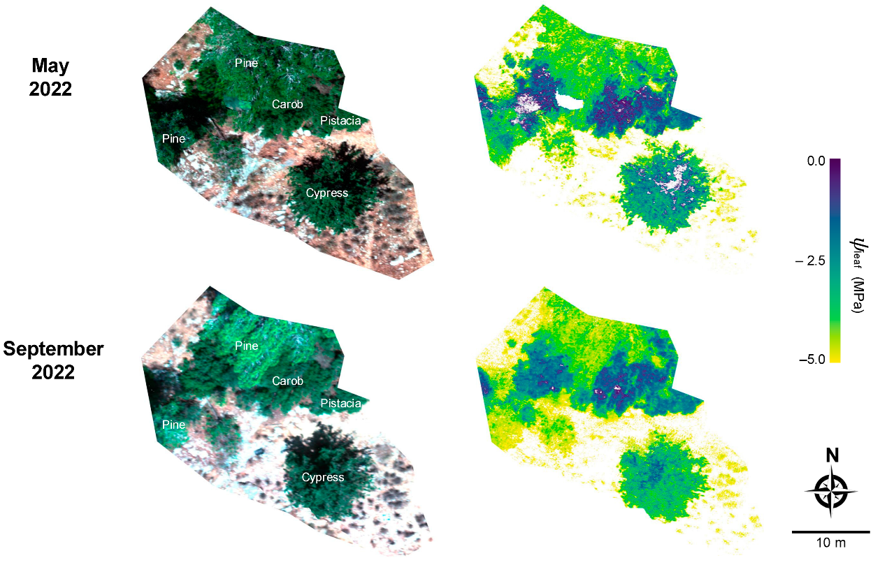

**Figure 10.** leaf map generated using the ‘general’ model and drone images acquired on two dates, one at the end of the dry season (September) and another at the end of the wet season (May).

Figure 11 presents the predicted ​leaf values for the region surrounding the study site (Yishi Forest), derived using the general model applied to satellite imagery. Due to the absence of a satellite sensor with the exact spectral bands required for the model at high spatial resolution, the prediction was performed using the closest available alternative—bands 11 and 8 (861 nm and 702 nm, respectively) from the *VENμS* satellite, which provides a spatial resolution of 5 meters (*VENμS* data site).

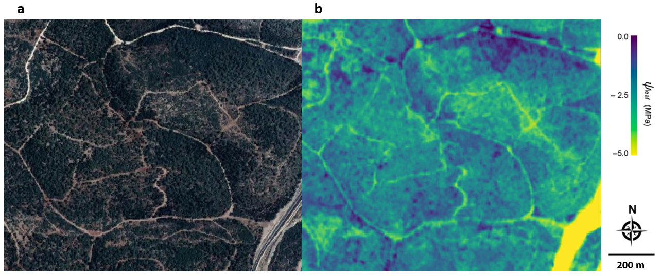

**Figure 11.** Predicted leaf values in Yishi Forest based on *VENμS* satellite imagery acquired in October 2022: (a) RGB composite image and (b) modeled leaf ​ values.

# 5. Discussion

This study explored the use of hyperspectral imaging and machine learning models to estimate leaf water potential (leaf) in a mixed Mediterranean forest, specifically hypothesizing that leaf would be easier to model from the spectral data for species with a broader range of leaf values. This proved true, as most models were significantly better for *Cypress* and *Pistacia*, which exhibited a more comprehensive range of leaf values throughout the season than the other species. It was also hypothesized that machine learning algorithms should significantly enhance the ability to predict leaf compared to simple linear regression models using spectral indices, specifically the non-linear models that account for more complex relationships. Indeed, findings from this study show that the SVM model was slightly superior to the simpler regression models using the spectral indices (Table 2 and Table 4). However, except for *Cypress* and *Pistacia*, SVM was not better than simple spectral indices in predicting leaf (Table 5). Overall, a simple linear regression model with commonly used vegetation indices, like NDVI, performed well enough to render the complex and data-demanding SVM model superfluous. Yet the general performance of SVM above RF and XGB may be related to its ability to learn effectively with small sample datasets, thus taking advantage of the sensitivity of its support vectors to all sample data points, including outliers (Kok et al., 2021). Also, SVM can map the dataset into high-dimensional input space, where it looks for core differences between classes using the optimal hyperplane, which might have given it an added advantage when species were added as part of the feature, leading to an increased accuracy from R2 of 0.35 to 0.53 (Table 4).

The observed variations in leaf among the five species (Fig. 5) align with previous findings by Peñuelas et al. (Peñuelas et al., 2017), reporting distinct water management characteristics in mixed Mediterranean forest species. This variability underscores the complexity of modeling water status in heterogeneous forest ecosystems. *Pine* exhibited the lowest average leaf (–2.56 MPa) and the least inter-annual variance. In contrast, *Cypress* and *Pistacia* demonstrated the most considerable leaf variance, reaching as low as –4.5 MPa during dry months. It is not surprising, then, that the model performance was much better for these two species. These species-specific differences in water potential dynamics highlight the importance of considering individual species’ physiological responses when developing forest water status assessment models, or at least considering stand density and species as factors.

As stated, most spectral indices showed a low correlation with leaf (Table 2), with NDVI being the best predictor, particularly for *Cypress* (R2 = 0.74). The other spectral indices tested in this study exhibited suboptimal performance despite their established correlation with plant water status in previous studies. This discrepancy may be attributed to the predominant focus of these indices on leaf water content rather than leaf (Azar et al., 2023; Jiang et al., 2008; Jr et al., 2011; Raj et al., 2021). While leaf water content directly influences spectral reflectance, leaf is a physiological parameter that reflects plant functionality and can vary in response to various factors, including water stress and changes in the ambient radiation environment. Elsayed et al. (2011) demonstrated the distinction between these parameters by developing indices specifically for leaf, independent of leaf water content. However, the disparity between their experimental design (controlled climate chamber, handheld spectrometer, crop plants) and this one (forest canopies, hyperspectral camera at 60 m height) may explain the limited applicability of their indices for this study. The results of this study suggest that these indices may not translate directly to forest stands under natural conditions, where factors such as canopy structure, background soil reflectance, and atmospheric effects can influence spectral measurements.

Although using different bands, findings align more closely with those of Stimson et al. (2005), who studied two conifer species (*Pinus edulis* and *Juniperus monosperma*) in a forest setting. They found that indices incorporating 980 nm and 1200 nm wavelength bands were significantly correlated with measured leaf, but the relationship differed between the two species. This species-specific variability is consistent with our observations, where *Cypress* and *Pistacia* showed stronger correlations with spectral indices than *Pine* and *Carob*. The high variability in leaf between species is also consistent with recent findings by Italiano et al. (2023), who reported significant differences in hydraulic traits among Mediterranean forest species.

The evaluation of machine learning models, including RF, XGB, and SVM, resulted in the SVM being the best model, particularly when incorporating species as a feature (Table 4). While Sadiq et al. (2023) and Virnodkar et al. (2020) focused on other vegetation characteristics rather than leaf specifically, their work demonstrates the broader potential of machine learning in remote sensing applications for forest assessment. In this study, the performance varied across species, with *Cypress* and *Pistacia* showing better predictability compared to *Pine*, *Oak*, and *Carob* (Fig. 8). This variation may be attributed to the higher inter-annual variance of leaf in *Cypress* and *Pistacia*, enabling stronger correlations between changes in leaf water potential and spectral indices. The improved performance of models incorporating species information highlights the importance of considering species-specific traits in mixed forest ecosystems. However, the practical application of such models in mixed forests remains challenging due to the difficulty in differentiating species in the image, especially when considering the most practical remote sensing use of satellites, which usually have a coarser spatial resolution. However, efforts seem successful in satellite and drone-based spectral differentiation of vegetation classes and types (e.g., (Weil et al., 2017, 2018)).

The ‘general’ model, averaging all species at the plot scale, has a greater potential for satellite remote sensing use. This is because it indicates that species differentiation is not required. This ‘general’ model is based on two bands, one within the red edge range (712 nm), which marks the inflection point from strong absorption by leaf chlorophyll in the visible region to structurally dominated reflectance in the NIR, which was the second band (816 nm) (Croft & Chen, 2018). This is not surprising since band centering within the red edge region is very sensitive to the slightest changes in chlorophyll content due to stress or LAI changes, resulting in either a blue shift – toward shorter wavelengths, or a red shift – toward longer wavelengths (Guyot et al., 1988; Thenkabail et al., 2016; Xie et al., 2018). The red and blue bands readily saturate at relatively low chlorophyll content or show an almost insignificant response to even small biochemical changes. Thus, the red-edge band is more likely to respond to changes in pigmentation and leaf cell or canopy structure. In contrast, bands within the visible regions are less sensitive to structure (Dong et al., 2019; Kumar et al., 2001).

The plot-scale approach may offer a more robust method for assessing forest water status over larger areas, potentially bridging the gap between individual leaf measurements and landscape-scale assessments using satellite imagery. The improved performance at the plot scale has important implications for forest management and ecological monitoring. It suggests that while individual tree-level predictions may be challenging due to high variability, aggregating data at a broader scale can provide reliable estimates of forest water status. This approach could be convenient for assessing drought stress across forest stands or informing management decisions in planted forests, which comprise approximately half of Israel's forested areas (Amir & Rechtman, 2006).

While promising, this ‘general’ model has two main limitations. First, it was generated at the plot scale, and the scalability to a finer scale, as shown in Figure 10, still needs to be verified. Nevertheless, the seasonal differences, with more negative leaf observed at the end of the dry season than at the end of the wet season, indicate that the model can reasonably capture temporal variations in forest water status. This temporal sensitivity is crucial for monitoring the impacts of seasonal drought and climate change on forest ecosystems, as highlighted by Allen et al. (2010) and reported by IPCC (2023), even though the magnitude might be inaccurate. Moreover, the clear differentiation between species in the modeled leaf, in accordance with the measured values, further strengthens our confidence in the model's ability to distinguish between species-specific water management strategies. The second limitation concerns the generality of the model. In other words, how reliable can this model be when transferred to another area? Since plots were relatively homogeneous in their species distribution, the model might need to be adjusted with, at least, a factor considering the stand density (when using satellite imagery) or/and by considering different species mixing at the pixel level. However, considering that the species in this study area are common Mediterranean species and the climate is typical of the Mediterranean region, the suggested model may be applied to similar regions elsewhere. Nevertheless, further testing should be conducted in different environments to ensure the model’s general applicability.

Finally, leaf is not a trivial parameter to detect directly and remotely. Without the invention of the pressure chamber and applying very high pressure (>50 bar in this study), it would have been very difficult to predict otherwise. Non-destructive leaf determination in the field by a few methods is still being tested. Thus, though challenging, our remote sensing effort to predict leaf proved successful and can be further used to detect leaf changes across mixed forest stands. Future research should include drought-stressed plots, which are the target of a future stress alert method.

# 6. Summary and Conclusion

Analysis using vegetation indices and various machine learning models on the entire dataset, without incorporating species information, resulted in weak to moderate correlations. The absence of a significant advantage for more complex ML models can be explained by the intrinsic variability in leaf spectral features across different species within the forest. When species information was included as a feature, the correlation improved for SVM but was still too weak to be superior to the simple spectral index model.

A ‘general’ plot scale model without species-specific differentiation performed much better. This finding is promising since the model can be used with satellite images to derive leaf at a coarser yet continuous spatial resolution. The fact that a ‘general’ model was better than all species-specific models highlights the inherent challenges of applying accurate remote sensing techniques in mixed-species forests, where interspecies variability is significant. These results suggest that plot-level aggregation may offer a more robust approach for assessing forest water status over larger areas. Still, such a conclusion must be further tested since the plots in our study area were relatively homogeneous regarding species distribution and density. In cases where fine-scale evaluation is required, and species classification is available, our findings indicate that the SVM model can be relatively effective in addressing these challenges.

This study’s approach facilitates precise monitoring of leaf, which can inform targeted forest conservation efforts, adaptive management strategies, and interventions tailored to species-specific drought vulnerabilities, thereby enhancing ecosystem resilience in the face of increasing drought stress.

# 7. References

Agussabti, Rahmaddiansyah, Satriyo, P., & Munawar, A. A. (2020). Data analysis on near infrared spectroscopy as a part of technology adoption for cocoa farmer in Aceh Province, Indonesia. *Data in Brief*, *29*, 105251. https://doi.org/10.1016/j.dib.2020.105251

Allen, C. D., Macalady, A. K., Chenchouni, H., Bachelet, D., McDowell, N., Vennetier, M., Kitzberger, T., Rigling, A., Breshears, D. D., Hogg, E. H. (Ted), Gonzalez, P., Fensham, R., Zhang, Z., Castro, J., Demidova, N., Lim, J.-H., Allard, G., Running, S. W., Semerci, A., & Cobb, N. (2010). A global overview of drought and heat-induced tree mortality reveals emerging climate change risks for forests. *Forest Ecology and Management*, *259*(4), 660–684. https://doi.org/https://doi.org/10.1016/j.foreco.2009.09.001

Amir, S., & Rechtman, O. (2006). The development of forest policy in Israel in the 20th century: implications for the future. *Forest Policy and Economics*, *8*(1), 35–51. https://doi.org/https://doi.org/10.1016/j.forpol.2004.05.003

Anderson, L. O., Malhi, Y., Aragão, L. E. O. C., Ladle, R., Arai, E., Barbier, N., & Phillips, O. (2010). Remote sensing detection of droughts in Amazonian forest canopies. *The New Phytologist*, *187*(3), 733–750. https://doi.org/10.1111/j.1469-8137.2010.03355.x

Asner, G. P., Martin, R. E., Anderson, C. B., Kryston, K., Vaughn, N., Knapp, D. E., Bentley, L. P., Shenkin, A., Salinas, N., Sinca, F., Tupayachi, R., Quispe Huaypar, K., Montoya Pillco, M., Ccori Álvarez, F. D., Díaz, S., Enquist, B. J., & Malhi, Y. (2017). Scale dependence of canopy trait distributions along a tropical forest elevation gradient. *The New Phytologist*, *214*(3), 973–988. https://doi.org/10.1111/nph.14068

Azar, M., Mulero, G., Yaara, O.-S., Helman, D., & Klein, T. (2023). Aboveground responses to belowground root damage detected by non-destructive sensing metrics in three tree species. *Forestry*.

Boyer, J. S. (1967). Leaf Water Potentials Measured with a Pressure Chamber. *Plant Physiology*, *42*(1), 133–137. https://doi.org/10.1104/pp.42.1.133

Breiman, L. (2001). Random Forests. *Machine Learning*, *45*(1), 5–32. https://doi.org/10.1023/A:1010933404324

Ceccato, P., Flasse, S., Tarantola, S., Jacquemoud, S., & Grégoire, J.-M. (2001). Detecting vegetation leaf water content using reflectance in the optical domain. *Remote Sensing of Environment*, *77*(1), 22–33. https://doi.org/https://doi.org/10.1016/S0034-4257(01)00191-2

Chen, T., & Guestrin, C. (2016). XGBoost: A scalable tree boosting system. *Proceedings of the 22nd ACM SIGKDD International Conference on Knowledge Discovery and Data Mining*, *13*-*17*-*Augu*, 785–794. https://doi.org/10.1145/2939672.2939785

Coops, N. C., Stone, C., Culvenor, D. S., Chisholm, L. A., & Merton, R. N. (2003). Chlorophyll content in eucalypt vegetation at the leaf and canopy scales as derived from high resolution spectral data. *Tree Physiology*, *23*(1), 23–31. https://doi.org/10.1093/treephys/23.1.23

Cortes, C., & Vapnik, V. (1995). Support-vector networks. *Machine Learning*, *20*(3), 273–297. https://doi.org/10.1007/BF00994018

Croft, H., & Chen, J. M. (2018). Leaf Pigment Content. *Comprehensive Remote Sensing*, *December*, 117–142. https://doi.org/10.1016/b978-0-12-409548-9.10547-0

Dong, T., Liu, J., Shang, J., Qian, B., Ma, B., Kovacs, J. M., Walters, D., Jiao, X., Geng, X., & Shi, Y. (2019). Assessment of red-edge vegetation indices for crop leaf area index estimation. *Remote Sensing of Environment*, *222*(May 2018), 133–143. https://doi.org/10.1016/j.rse.2018.12.032

Elsayed, S., Mistele, B., & Schmidhalter, U. (2011). Can changes in leaf water potential be assessed spectrally? *Functional Plant Biology : FPB*, *38*(6), 523–533. https://doi.org/10.1071/FP11021

Fassnacht, F. E., Latifi, H., Stereńczak, K., Modzelewska, A., Lefsky, M., Waser, L. T., Straub, C., & Ghosh, A. (2016). Review of studies on tree species classification from remotely sensed data. *Remote Sensing of Environment*, *186*, 64–87. https://doi.org/https://doi.org/10.1016/j.rse.2016.08.013

Gamon, J. A., Peñuelas, J., & Field, C. B. (1992). A narrow-waveband spectral index that tracks diurnal changes in photosynthetic efficiency. *Remote Sensing of Environment*, *41*(1), 35–44. https://doi.org/https://doi.org/10.1016/0034-4257(92)90059-S

Gao, B. (1996). NDWI—A normalized difference water index for remote sensing of vegetation liquid water from space. *Remote Sensing of Environment*, *58*(3), 257–266. https://doi.org/https://doi.org/10.1016/S0034-4257(96)00067-3

Guyot, G., Baret, F., & Major, D. J. (1988). High spectral resolution: Determination of spectral shifts between the red and infrared. *International Archives of Photogrammetry and Remote Sensing*, *11*(1), 750–760. https://doi.org/10.1093/mind/VII.25.101

Hartmann, H., Moura, C. F., Anderegg, W. R. L., Ruehr, N. K., Salmon, Y., Allen, C. D., Arndt, S. K., Breshears, D. D., Davi, H., Galbraith, D., Ruthrof, K. X., Wunder, J., Adams, H. D., Bloemen, J., Cailleret, M., Cobb, R., Gessler, A., Grams, T. E. E., Jansen, S., … O’Brien, M. (2018). Research frontiers for improving our understanding of drought-induced tree and forest mortality. *The New Phytologist*, *218*(1), 15–28. https://doi.org/10.1111/nph.15048

Helman, D., Bahat, I., Netzer, Y., Ben-Gal, A., Alchanatis, V., Peeters, A., & Cohen, Y. (2018). Using Time Series of High-Resolution Planet Satellite Images to Monitor Grapevine Stem Water Potential in Commercial Vineyards. *Remote Sensing*, *10*(10). https://doi.org/10.3390/rs10101615

Helman, D., & Mussery, A. (2020a). Using Landsat satellites to assess the impact of check dams built across erosive gullies on vegetation rehabilitation. *Science of The Total Environment*, *730*, 138873. https://doi.org/https://doi.org/10.1016/j.scitotenv.2020.138873

Helman, D., & Mussery, A. (2020b). Using Landsat satellites to assess the impact of check dams built across erosive gullies on vegetation rehabilitation. *Science of the Total Environment*, *730*. https://doi.org/10.1016/j.scitotenv.2020.138873

Helman, D., Osem, Y., Yakir, D., & Lensky, I. M. (2017). Relationships between climate , topography , water use and productivity in two key Mediterranean forest types with different water-use strategies. *Agricultural and Forest Meteorology*, *232*, 319–330. https://doi.org/10.1016/j.agrformet.2016.08.018

Helman, D., Yungstein, Y., Mulero, G., & Michael, Y. (2022). High-Throughput Remote Sensing of Vertical Green Living Walls (VGWs) in Workplaces. *Remote Sensing*, *14*(14). https://doi.org/10.3390/rs14143485

Inoue, Y., Peñuelas, J., Miyata, A., & Mano, M. (2008). Normalized difference spectral indices for estimating photosynthetic efficiency and capacity at a canopy scale derived from hyperspectral and CO2 flux measurements in rice. *Remote Sensing of Environment*, *112*(1), 156–172. https://doi.org/10.1016/j.rse.2007.04.011

IPCC. (2023). *Climate Change 2023: Synthesis Report. Contribution of Working Groups I, II and III to the Sixth Assessment Report of the Intergovernmental Panel on Climate Change [Core Writing Team, H. Lee and J. Romero (eds.)]*. https://doi.org/10.59327/IPCC/AR6-9789291691647.001

*Israel Meteorological Service*. (n.d.). Israel.

Italiano, S. S. P., Julio Camarero, J., Borghetti, M., Colangelo, M., Pizarro, M., & Ripullone, F. (2023). Radial growth, wood anatomical traits and remote sensing indexes reflect different impacts of drought on Mediterranean forests. *Forest Ecology and Management*, *548*, 121406. https://doi.org/https://doi.org/10.1016/j.foreco.2023.121406

Jarvis, P. G. (1976). The Interpretation of the Variations in Leaf Water Potential and Stomatal Conductance Found in Canopies in the Field. *Philosophical Transactions of the Royal Society of London. Series B, Biological Sciences*, *273*(927), 593–610.

Jiang, Z., Huete, A. R., Didan, K., & Miura, T. (2008). Development of a two-band enhanced vegetation index without a blue band. *Remote Sensing of Environment*, *112*(10), 3833–3845. https://doi.org/https://doi.org/10.1016/j.rse.2008.06.006

Jr, H., Daughtry, C., Qu, J., Wang, L., & Hao, X. (2011). Comparison of hyperspectral retrievals with vegetation water indices for leaf and canopy water content. *Proceedings of SPIE - The International Society for Optical Engineering*, *8156*, 5. https://doi.org/10.1117/12.895293

Kerr, J. T., & Ostrovsky, M. (2003). From space to species: ecological applications for remote sensing. *Trends in Ecology & Evolution*, *18*(6), 299–305. https://doi.org/https://doi.org/10.1016/S0169-5347(03)00071-5

Klein, T., Cahanovitc, R., Sprintsin, M., Herr, N., & Schiller, G. (2019). A nation-wide analysis of tree mortality under climate change: Forest loss and its causes in Israel 1948–2017. *Forest Ecology and Management*, *432*, 840–849. https://doi.org/https://doi.org/10.1016/j.foreco.2018.10.020

Kok, Z. H., Mohamed Shariff, A. R., Alfatni, M. S. M., & Khairunniza-Bejo, S. (2021). Support Vector Machine in Precision Agriculture: A review. *Computers and Electronics in Agriculture*, *191*, 106546. https://doi.org/https://doi.org/10.1016/j.compag.2021.106546

Konings, A. G., & Gentine, P. (2017). Global variations in ecosystem-scale isohydricity. *Global Change Biology*, *23*(2), 891–905. https://doi.org/10.1111/gcb.13389

Konings, A. G., Rao, K., & Steele-Dunne, S. C. (2019). Macro to micro: microwave remote sensing of plant water content for physiology and ecology. *New Phytologist*, *223*(3), 1166–1172. https://doi.org/10.1111/nph.15808

Kriegler, F. J., Malila, W. A., Nalepka, R. F., & Richardson, W. (1969). *Preprocessing Transformations and Their Effects on Multispectral Recognition*.

Kumar, L., Schmidt, K., Dury, S., & Skidmore, A. (2001). *Imaging Spectrometry and Vegetation Science BT - Imaging Spectrometry: Basic Principles and Prospective Applications* (F. D. van der Meer & S. M. De Jong (Eds.); pp. 111–155). Springer Netherlands. https://doi.org/10.1007/978-0-306-47578-8_5

Lapidot, O., Ignat, T., Rud, R., Rog, I., Alchanatis, V., & Klein, T. (2019). Use of thermal imaging to detect evaporative cooling in coniferous and broadleaved tree species of the Mediterranean maquis. *Agricultural and Forest Meteorology*, *271*(September 2018), 285–294. https://doi.org/10.1016/j.agrformet.2019.02.014

Li, J., Wijewardane, N. K., Ge, Y., & Shi, Y. (2023). Improved chlorophyll and water content estimations at leaf level with a hybrid radiative transfer and machine learning model. *Computers and Electronics in Agriculture*, *206*, 107669. https://doi.org/https://doi.org/10.1016/j.compag.2023.107669

Li, W., Pacheco-Labrador, J., Migliavacca, M., Miralles, D., Hoek van Dijke, A., Reichstein, M., Forkel, M., Zhang, W., Frankenberg, C., Panwar, A., Zhang, Q., Weber, U., Gentine, P., & Orth, R. (2023). Widespread and complex drought effects on vegetation physiology inferred from space. *Nature Communications*, *14*(1), 4640. https://doi.org/10.1038/s41467-023-40226-9

McFeeters, S. K. (1996). The use of the Normalized Difference Water Index (NDWI) in the delineation of open water features. *International Journal of Remote Sensing*, *17*(7), 1425–1432. https://doi.org/10.1080/01431169608948714

Mouazen, A. M., De Baerdemaeker, J., & Ramon, H. (2006). Effect of wavelength range on the measurement accuracy of some selected soil constituents using visual-near infrared spectroscopy. *Journal of Near Infrared Spectroscopy*, *14*(3), 189–199. https://doi.org/10.1255/jnirs.614

Mulero, G., Jiang, D., Bonfil, D. J., & Helman, D. (2023). Use of thermal imaging and the photochemical reflectance index (PRI) to detect wheat response to elevated CO2 and drought. *Plant, Cell & Environment*, *46*(1), 76–92. https://doi.org/https://doi.org/10.1111/pce.14472

Othman, Y., Steele, C., VanLeeuwen, D., Heerema, R., Bawazir, S., & St. Hilaire, R. (2014). Remote sensing used to detect moisture status of pecan orchards grown in a desert environment. *International Journal of Remote Sensing*, *35*(3), 949–966. https://doi.org/10.1080/01431161.2013.873834

Patsiou, T. S., Shestakova, T. A., Klein, T., di Matteo, G., Sbay, H., Chambel, M. R., Zas, R., & Voltas, J. (2020). Intraspecific responses to climate reveal nonintuitive warming impacts on a widespread thermophilic conifer. *New Phytologist*, *n/a*(n/a). https://doi.org/10.1111/nph.16656

Peñuelas, J., Filella, I., Biel, C., Serrano, L., & Savé, R. (1993). The reflectance at the 950–970 nm region as an indicator of plant water status. *International Journal of Remote Sensing*, *14*(10), 1887–1905. https://doi.org/10.1080/01431169308954010

Peñuelas, J., Fillla, I., Serrano, L., & Savé, R. (1996). Cell wall elasticity and Water Index (R970 nm/R900 nm) in wheat under different nitrogen availabilities. *International Journal of Remote Sensing*, *17*(2), 373–382. https://doi.org/10.1080/01431169608949012

Peñuelas, J., Sardans, J., Filella, I., Estiarte, M., Llusià, J., Ogaya, R., Carnicer, J., Bartrons, M., Rivas-Ubach, A., Grau, O., Peguero, G., Margalef, O., Pla-Rabés, S., Stefanescu, C., Asensio, D., Preece, C., Liu, L., Verger, A., Barbeta, A., … Terradas, J. (2017). Impacts of Global Change on Mediterranean Forests and Their Services. In *Forests* (Vol. 8, Issue 12). https://doi.org/10.3390/f8120463

Pinhanez, C. S., & Cavalin, P. R. (2022). Exploring the Advantages of Dense-Vector to One-Hot Encoding of Intent Classes in Out-of-Scope Detection Tasks. *ArXiv*, *abs/2205.0*.

Pozner, E., Bar-On, P., Livne-Luzon, S., Moran, U., Tsamir-Rimon, M., Dener, E., Schwartz, E., Rotenberg, E., Tatarinov, F., Preisler, Y., Zecharia, N., Osem, Y., Yakir, D., & Klein, T. (2022). A hidden mechanism of forest loss under climate change: The role of drought in eliminating forest regeneration at the edge of its distribution. *Forest Ecology and Management*, *506*, 119966. https://doi.org/https://doi.org/10.1016/j.foreco.2021.119966

Raj, R., Walker, J. P., Vinod, V., Pingale, R., Naik, B., & Jagarlapudi, A. (2021). Leaf water content estimation using top-of-canopy airborne hyperspectral data. *International Journal of Applied Earth Observation and Geoinformation*, *102*, 102393. https://doi.org/https://doi.org/10.1016/j.jag.2021.102393

Ritchie, G. A., & Hinckley, T. M. (1975). The Pressure Chamber as an Instrument for Ecological Research. *Advances in Ecological Research*, *9*(C), 165–254. https://doi.org/10.1016/S0065-2504(08)60290-1

Roberts, D. A., Barbara, S., Roth, K., & Perroy, R. L. (2011). Spectral and Spatial Methods of Hyperspectral Image Analysis for Estimation of Biophysical and Biochemical Properties of Agricultural Crops. In *Hyperspectral Remote Sensing of Vegetation* (Issue April 2016). https://doi.org/10.1201/b11222-20

Rog, I., Hilman, B., Fox, H., Yalin, D., Qubaja, R., & Klein, T. (2024). Increased belowground tree carbon allocation in a mature mixed forest in a dry versus a wet year. *Global Change Biology*, *30*(2), e17172. https://doi.org/https://doi.org/10.1111/gcb.17172

Rog, I., Tague, C., Jakoby, G., Megidish, S., Yaakobi, A., Wagner, Y., & Klein, T. (2021). Interspecific Soil Water Partitioning as a Driver of Increased Productivity in a Diverse Mixed Mediterranean Forest. *Journal of Geophysical Research: Biogeosciences*, *126*.

Sack, L., Ball, M., Brodersen, C., Davis, S., Des Marais, D., Donovan, L., Givnish, T., Hacke, U., Huxman, T., Jansen, S., Jacobsen, A., Johnson, D., Koch, G., Maurel, C., McCulloh, K., McDowell, N., Mcelrone, A., Meinzer, F., Melcher, P., & Holbrook, N. (2016). Plant hydraulics as a central hub integrating plant and ecosystem function: Meeting report for “Emerging Frontiers in Plant Hydraulics” (Washington, DC, May 2015). *Plant, Cell & Environment*, *39*. https://doi.org/10.1111/pce.12732

Sadeh, R., Avneri, A., Tubul, Y., Lati, R. N., Bonfil, D. J., Peleg, Z., & Herrmann, I. (2024). Chickpea leaf water potential estimation from ground and VENµS satellite. *Precision Agriculture*, *25*(3), 1658–1683. https://doi.org/10.1007/s11119-024-10129-w

Sadiq, M. A., Sarkar, S. K., & Raisa, S. S. (2023). Meteorological drought assessment in northern Bangladesh: A machine learning-based approach considering remote sensing indices. *Ecological Indicators*, *157*, 111233. https://doi.org/https://doi.org/10.1016/j.ecolind.2023.111233

Sahoo, M. M., Perach, O., Shachter, A., Gonda, I., Porwal, A., Dudai, N., & Herrmann, I. (2022). Spectral estimation of carnosic acid content in in vivo rosemary plants. *Industrial Crops and Products*, *187*, 115292. https://doi.org/https://doi.org/10.1016/j.indcrop.2022.115292

Savitzky, A., & Golay, M. J. E. (1964). Smoothing and Differentiation of Data by Simplified Least Squares Procedures. *Analytical Chemistry*, *36*(8), 1627–1639. https://doi.org/10.1021/ac60214a047

Scholander, P. F., Bradstreet, E. D., Hemmingsen, E. A., & Hammel, H. T. (1965). Sap Pressure in Vascular Plants. *Science*, *148*(3668), 339–346. https://doi.org/10.1126/science.148.3668.339

Sternberg, M., Golodets, C., Gutman, M., Perevolotsky, A., Kigel, J., & Henkin, Z. (2017). No precipitation legacy effects on above-ground net primary production and species diversity in grazed Mediterranean grassland: a 21-year experiment. *Journal of Vegetation Science*, *28*(2), 260–269. https://doi.org/https://doi.org/10.1111/jvs.12478

Stimson, H. C., Breshears, D. D., Ustin, S. L., & Kefauver, S. C. (2005). Spectral sensing of foliar water conditions in two co-occurring conifer species: Pinus edulis and Juniperus monosperma. *Remote Sensing of Environment*, *96*(1), 108–118. https://doi.org/https://doi.org/10.1016/j.rse.2004.12.007

Thenkabail, P. S., Lyon, J. G., & Huete, A. (2016). *Hyperspectral Remote Sensing of Vegetation*. CRC Press, Boca Raton, FL, USA.

Thenkabail, P. S., Lyon, J. G., & Huete, A. (2018). Hyperspectral Indices and Image Classifications for Agriculture and Vegetation. In *Hyperspectral Indices and Image Classifications for Agriculture and Vegetation*. https://doi.org/10.1201/9781315159331

Ullah, S., Skidmore, A. K., Naeem, M., & Schlerf, M. (2012). An accurate retrieval of leaf water content from mid to thermal infrared spectra using continuous wavelet analysis. *Science of The Total Environment*, *437*, 145–152. https://doi.org/https://doi.org/10.1016/j.scitotenv.2012.08.025

Virnodkar, S. S., Pachghare, V. K., Patil, V. C., & Jha, S. K. (2020). Remote sensing and machine learning for crop water stress determination in various crops: a critical review. *Precision Agriculture*, *21*(5), 1121–1155. https://doi.org/10.1007/s11119-020-09711-9

Wang, Z., Sun, Z., & Lu, S. (2020). Optimal vegetation index for assessing leaf water potential using reflectance factors from the adaxial and abaxial surfaces. *Computers and Electronics in Agriculture*, *172*(May 2018), 105337. https://doi.org/10.1016/j.compag.2020.105337

Weil, G., Lensky, I. M., & Levin, N. (2017). Using ground observations of a digital camera in the VIS-NIR range for quantifying the phenology of Mediterranean woody species. *International Journal of Applied Earth Observation and Geoinformation*, *62*, 88–101. https://doi.org/https://doi.org/10.1016/j.jag.2017.05.016

Weil, G., Lensky, I. M., Resheff, Y. S., & Levin, N. (2018). Using Near-Surface Observations for Optimizing the Timing of Overhead Image Acquisition for Applied Mapping of Woody Vegetation Species. *IGARSS 2018 - 2018 IEEE International Geoscience and Remote Sensing Symposium*, 5398–5401. https://doi.org/10.1109/IGARSS.2018.8517691

Xie, Q., Dash, J., Huang, W., Peng, D., Qin, Q., Mortimer, H., Casa, R., Pignatti, S., Laneve, G., Pascucci, S., Dong, Y., & Ye, H. (2018). Vegetation Indices Combining the Red and Red-Edge Spectral Information for Leaf Area Index Retrieval. *IEEE Journal of Selected Topics in Applied Earth Observations and Remote Sensing*, *11*(5), 1482–1492. https://doi.org/10.1109/JSTARS.2018.2813281

Zarco-Tejada, P. J., Rueda, C. A., & Ustin, S. L. (2003). Water content estimation in vegetation with MODIS reflectance data and model inversion methods. *Remote Sensing of Environment*, *85*(1), 109–124. https://doi.org/https://doi.org/10.1016/S0034-4257(02)00197-9

VENμS data site: https://venus.bgu.ac.il/venus/

# Supplements

**Supplementary Table 1.** Optimized hyperparameters for Random Forest (RF), Support Vector Machine (SVM), and XGBoost (XGB). Models implemented using the scikit-learn library in Python. Models were trained on two datasets: NDSI alone and NDSI with species data.

|  |  |  |  |
| --- | --- | --- | --- |
| Model | *Hyperparameter* | *NDSI* | *NDSI +Species* |
| *RF* | max_depth | 30 | 110 |
| max_features | sqrt | sqrt |
| min_samples_split | 5 | 2 |
| n_estimators | 400 | 1000 |
| *SVM* | C | 80 | 14 |
| Coef0 | 1.03 | 0.33 |
| degree | 2 | 3 |
| epsilon | 0.7 | 0.44 |
| gamma | 2.04 | 1.22 |
| kernel | rbf | rbf |
| tol | 2.00e-04 | 6.84e-05 |
| *XGB* | subsample | 0.74 | 0.18 |
| reg_lambda | 0.8 | 0.88 |
| reg_alpha | 0.8 | 0.8 |
| n_estimators | 1150 | 1150 |
| min_child_weight | 2 | 2 |
| max_depth | 4 | 3 |
| learning_rate | 0.01 | 0.01 |
| colsample_bytree | 0.9 | 0.99 |

******Supplementary Figure 1.** Correlation maps of all possible two-band combinations with normalized difference vegetation index (NDSI) the measured leaf (N = 246). 5 points marked on the map represent local maxima with their corresponding Pearson’s R value (*p < 0.001*).

**Supplementary Figure 2.** Correlation maps of all possible two-band combinations with normalized difference vegetation index (NDSI) the measured leaf over the entire plot average (N = 56). The best performing two band combinations is based on the max R (*p < 0.001*).

# תקציר

פוטנציאל מים בעלה (פמ"ע) הוא מדד מרכזי למצב משק המים בצמחים בכלל ובעצים בפרט, אך מדידתו בשיטה מסורתית דורשת עבודה רבה ולכן מוגבלת בכיסוי המרחבי שלה. שיטות חישה מרחוק מציעות פתרון מבטיח להערכת מצב המים בצומח, אך הפוטנציאל של הדמיה היפרספקטרלית בתחום זה עדיין לא מוצה, במיוחד ביערות ים תיכוניים מעורבים.

במחקר זה נעשה שימוש במדדים ספקטרליים שהופקו מתמונות היפרספקטרליות שצולמו באמצעות רחפן, בשילוב עם אלגוריתמים של למידת מכונה, כדי להעריך פמ"ע ביער ים-תיכוני מעורב. המחקר נערך ביער ישעי, הכולל חמישה מיני עצים עיקריים: אורן ירושלים (Pinus halepensis), אלון מצוי (Quercus calliprinos), ברוש מצוי (Cupressus sempervirens), חרוב מצוי (Ceratonia siliqua) ואלת המסטיק (Pistacia lentiscus). דימותים היפרספקטרליים (400-1000 ננומטר) צולמו אחת לחודש במשך שנה, במקביל למדידות ידניות ישירות של פמ"ע על ידי תא לחץ של כל המינים. נבחנו 12 מדדים ספקטרליים ידועים לצד מעל 37,000 צירופי מדדים ספקטרליים מנורמלים (NDSI) להשגת מתאם אל מול ערכי הפמ"ע.

לצורך בניית מודלי חיזוי נעשה שימוש בשלושה אלגוריתמים של למידת מכונה – Random Forest (RF) eXtreme Gradient Boosting (XGBoost) ו-Support Vector Machine (SVM) . ביצועי מודלים אלה הושוו למודלים ליניאריים המבוססים על מדדים ספקטרליים. נמצא כי המודל המדויק ביותר היה SVM, במיוחד כאשר מידע על המין שולב כמשתנה נוסף במודל (R2 = 0.53; RMSE = 0.67 MPa; rRMSE = 28%). הביצועים הטובים ביותר נרשמו עבור הברוש (R2 = 0.80) והאלה(R2 = 0.49), שהראו את התנודתיות הגדולה ביותר בפמ"ע לאורך השנה.

בנוסף, נמצא כי מודל כללי שאינו מתייחס להבדלים בין מינים, אלא מחשב את ממוצע הנתונים ברמת החלקה כולה, שיפר משמעותית את יכולת החיזוי (R2 = 0.79, RMSE = 0.31 MPa; rRMSE = 13%). תוצאה זו מרמזת כי ניתן ליישם גישה זו גם באמצעות נתוני לוויין ברזולוציה גסה יותר.

ממצאי המחקר מראים כי שילוב של הדמיה היפרספקטרלית עם אלגוריתמים של למידת מכונה מאפשר הערכה מדויקת של מצב המים ביערות מעורבים. גישה זו מהווה כלי מבטיח לניטור עקת יובש ולסיוע בקבלת החלטות ניהוליות ביערות מעורבים ים-תיכוניים, תוך הדגשת האתגרים הקיימים בזיהוי שינויים תוך-מיניים באמצעות חישה מרחוק.

**פוטנציאל מים בעלה ביער ים תיכוני מעורב באמצעות חישה היפר ספקטרלית מרחפן ולמידת מכונה**  
  
  
  
עבודת-גמר  
מוגשת לפקולטה לחקלאות, מזון וסביבה ע"ש רוברט ה. סמית  
  
האוניברסיטה העברית בירושלים  
  
  
**לשם קבלת תואר  
'מוסמך למדעי החקלאות'**  
  
  
ע"י  
נתנאל פישמן

|  |  |  |
| --- | --- | --- |
| סיון התשפ"ה | רחובות | יוני 2025 |